**UNIVERSITY of SCIENCE and TECHNOLOGY BEIJING**

**ENVIRONMENTAL MICROBIOLOGY**

PAPER WORK

Progress of Research on Microbes for Nitrogen Removal

Name：SAHR EMMANUEL （伊曼沙)

Student ID： M202161014

Teacher：LI TIANXIN

[Due Date]

# Abstract

**Keywords**:

# Introduction

In the United States, India, China and other overpopulated countries, underground water is already overexploited, and providing enough water to sustain a burgeoning population while balancing all other demands on the water is one of the century's greatest challenges. Between 2000 and 2050, the number of people living in river basins under severe water stress is expected to more than double, reaching 3.9 billion. Almost a fifth of the world's population does not have access to safe drinking water, and this problem is a leading cause of mortality and disease, with over 14000 people dying every day. Currently, the demand for water is increasing on natural systems, and immediate actions must be done to begin implementing established and effective wastewater treatment procedures before the situation spirals out of control. The increased use of fertilizers in agriculture has been reported to contaminate surface and groundwater sources in Canada with approximately 293,000 tonnes of nitrogen per year. Furthermore, numerous types of waste, including industrial, animal, and home waste, cause nitrogen contamination of water when they are dumped into untreated water sources. Municipal wastewater treatment plants (WWTPs) contribute approximately 80,000 tonnes of nitrogen to surface and ground waters each year . One of the direct and harmful consequences of excessive nitrogen loading is eutrophication in freshwater ecosystems. Eutrophication degrades freshwater ecosystems by causing algal blooms, spreading aquatic plants, oxygen depletion, and thus the extinction of key species (Taziki et al., 2015). Furthermore, blue-green algae blooms can generate natural toxins that are harmful to human health.

Fixed nitrogen, such as ammonium and nitrate, must be removed from organic contaminants to prevent eutrophication in water bodies. Lower NH3-N concentrations of 1.68 mg/l were also shown to be hazardous to fish flora. Because nitrifying bacteria consume dissolved oxygen (DO) while oxidizing ammonia to nitrite and nitrate, ammonia creates an oxygen demand in natural water systems. Nitrate levels more than 10 ppm may pose a major health risk to newborns and pregnant or nursing women. Many countries have strict nitrogen discharge standards in place. In China, for example, municipal WWTPs are permitted to discharge no more than 5 mg L-1 ammonium and 15 mg L-1 total nitrogen (GB18918-2002). Thus, nitrogen removal from wastewaters is critical for protecting water resources, particularly in water-stressed areas.

Nitrogen exists in several oxidation states and forms, making its removal from water a complex and difficult process. Because of the stability and high solubility of nitrate, adsorption or coprecipitation treatment is frequently not practicable, resulting in high energy and expense for treating nitrate-contaminated water. Most wastewater treatment systems include two levels of treatment: primary (physical settling of particles) and secondary (various forms of biological oxidation e.g. activated sludge or trickling filters). Tertiary treatment is also utilized for nutrient removal and disinfection in locations where rules require higher effluent quality. Tertiary treatment, as the ultimate cleaning step, eliminates inorganic compounds and improves effluent quality before it is reused, recycled, or discharged into the environment.

# Nitrification

Nitrification is the biological process of converting ammonium to nitrate. Nitrosomonas bacteria are used in this method to convert ammonium and ammonia into nitrite in two stages. Nitrobacteria is eventually used in the process of converting nitrite to nitrate. The Gram-negative autotrophic bacteria AOB and NOB are phylogenetically unrelated genera of Gram-negative autotrophic bacteria that are responsible for aerobic nitrification. Nitrosomonas, Nitrosospira, Nitrosovibrio, and Nitrosolobus are members of the -subclass proteobacteria, whereas Nitrosococcus is a member of the -subclass proteobacteria. A total of 25 AOB species have been gathered from varied settings, with some of them capable of growing in both aerobic and anaerobic situations. Surprisingly, the nitrification products of AOB species differ depending on the availability of DO. Nitrococcus and Nitrobacter genera belong to the -α and -γ subclasses, respectively.



Based on bacterial metabolisms, the traditional biological nitrogen removal idea involves successive nitrification and denitrification.

### ***1.1.1. Properties and Characteristics of nitrifying bacteria***

Nitrification, a two-step process of converting ammonia to nitrate via nitrite, is catalyzed by chemolithoautotrophic bacteria that oxidize either ammonia or nitrite. The Gram-negative autotrophic bacteria AOB and NOB are phylogenetically unrelated genera of Gram-negative autotrophic bacteria that are responsible for aerobic nitrification. They derive energy and carbon from ammonia oxidation and CO2, respectively, and utilize oxygen as the terminal electron acceptor. AOB have a multi-layered cell wall shape and move via flagella. Nitrosomonas, Nitrosospira, Nitrosovibrio, and Nitrosolobus are among the five identified genera of AOB, with only Nitrosococcus from the -subclass proteobacteria. A total of 25 AOB species have been gathered from various settings, with some of them capable of growing in both aerobic and anaerobic environments. Surprisingly, the nitrification products of AOB species differ depending on the availability of DO. Nitrosomonas eutropha aerobic oxidation product, for example, is only nitrite at DO greater than 0.8 mg L-1, although other products such as nitrogen gas, nitrite, and nitric oxides are formed at DO less than 0.8 mg L-1.

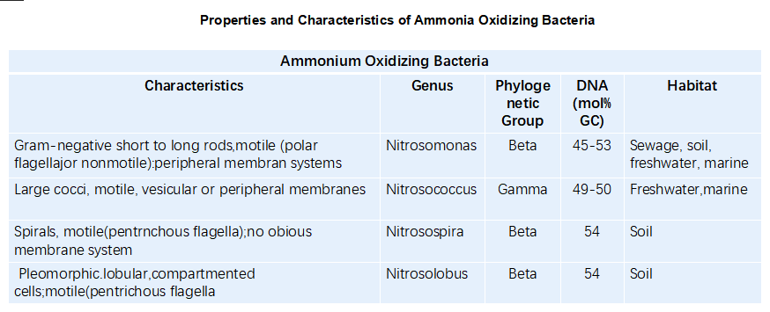Table 1 Properties and Characteristics of some (AOB) nitrifying bacteria

NOB are more common than AOB and are divided into four phylogenetically separate groupings. Nitrococcus and Nitrobacter genera belong to the - and -subclasses, respectively. Meanwhile, the Nitrospira genus, which includes Candidatus Nitrospira defluvii, has been assigned to the -subclass. The recent characterisation of Nitrospira, a full nitrifying bacteria that performs a process known as Comammox, has fundamentally altered the picture of microbial nitrification. During growth, this organism expresses ammonia and nitrite oxidation pathways simultaneously, resulting in ammonia oxidation to nitrate.

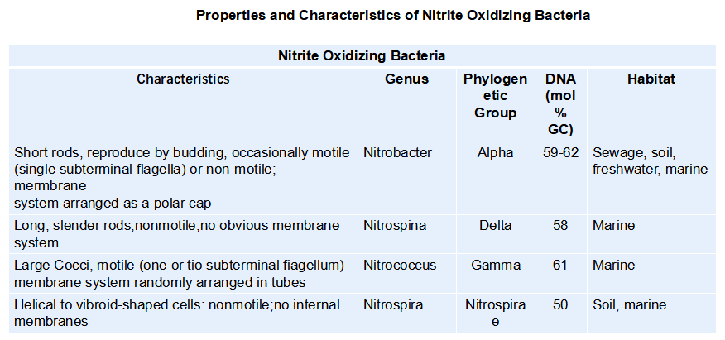Table 2 Table 1 Properties and Characteristics of some (NOB) nitrifying bacteria

### ***1.1.2 Purification theory of Nitrifying Bacterial***

To begin, autotrophic Ammonia-oxidizing bacteria (AOB) oxidize ammonium (NH4+) to nitrite (NO2) via hydroxylamine (NH2OH) in the first phase of nitrification (reactions 1 and 2, below). Because of the high rate of reactions, nitrite concentrations are often low. A long retention time, a low food to microorganisms ratio, and a suitable amount of buffer are all required for an efficient nitrification process.

(1)

(2)

(3)



These two processes are catalyzed by membrane-bound ammonia monooxygenase (AMO) and hydroxylamine oxidoreductase (HAO). In the second phase, nitrite-oxidizing bacteria (NOB) use membrane-bound nitrite oxidoreductase (NOR) to convert nitrite to nitrate (NO3) (reaction 3).

Oxidation of ammonia is best carried out at a pH of 7.5 to 8.0 at a temperature of 25 to 30C. Inorganic carbon reduction requires a significant amount of energy, which results in long generation times for AOB, ranging from 8 hours to several days. This means that AOB has low growth rates and yields. AOB is not the only ammonia oxidizer found in drinking water systems; archaea have also been found in recent studies, although their importance in the nitrification of the distribution system is yet unknown.

### ***1.1.3 Factors that Influence the Rate of Nitrification***

The presence of ammonia, dissolved oxygen (DO), pH, light, temperature, alkalinity, and inorganic and organic carbon sources are just a few of the many variables. They all have an effect on the bacteria responsible for nitrification.

* Ammonia is present

Nitrifying bacteria require external energy sources such as ammonia, nitrite, and urea to function. Since they are essential to nitrification, they cannot be omitted.

* Dissolved Oxygen (DO)

Nitrifying bacteria use dissolved oxygen (DO) as a source of energy. Nitrogen is required for nitrification at a concentration greater than 1 mg/L. Each milligram of ammonia that is converted to nitrite needs 4.33 milligrams of oxygen to be converted effectively. When oxygen is scarce, ammonia oxidizers fall back on nitrite or nitrate as an electron acceptor. Corrosion, for example, can consume a small quantity of oxygen by establishing an aerobic microbial environment, which increases both process efficiency and output.

* Temperature

Temperature accelerates biological responses by altering the speeds of enzyme reactions and substrate transport on biofilm. Temperatures between 4°C and 45°C are ideal for nitrifier growth. A temperature range of 30°C to 35°C is ideal for this process. The nitrification rate is nil for temperatures greater than 40°C and lower than 10°C. Nitrosmonas and nitrobacter thrive best at 35°C and 35-42°C, respectively, in a pure culture. AOB and NOB activated sludge perform best at a temperature of about 30°C. The nitrification process now has different optimal temperatures thanks to research done by scientists.

* Light

Limiting factors for the nitrification process include visible and ultraviolet light. Allen and Preston found that nitrifying bacteria grow more rapidly in biofilms that are deeper and exposed to less light. According to Alleman et al., nitrifying bacteria can regenerate after being exposed to light for 4 to 6 hours or more.

* pH

In the range of pH (4.6 to 11.2), the nitrification process takes place Nitrification generates acid as a byproduct. The pH requirement for nitrifying bacteria is raised by this acid. The rate of nitrification drops below 6 pH. There is an ideal pH range for this process of 7.5 to 8.5. This is because the concentration of free ammonia changes owing to changes in pH, and these fluctuations are used as substrates for ammonia oxidation.

* Alkalinity and inorganic carbon are two key concepts to understand.

14 mg CaCO3 is consumed for every milligram of NH4+ -N in the oxidation process of ammonia to nitrate. The neutralization of hydrogen ions necessitates the use of a large amount of alkali in ammonia oxidation. Autotrophic, nitrifying bacteria obtain their carbon from inorganic sources. For an adequate buffer level, more than 50-100 mg/L alkali is needed.

* Carbon Composition: Organic

Organic carbon has a negative impact on the nitrification process because of the toxicity of the chemicals and the struggle for nutrients between nitrifying and heterotrophic bacteria.

# Denitrification

Denitrification is the process of completely removing nitrate and converting it to harmless nitrogen gas as the end product, with minimal waste brine generation. Denitrification treats multiple pollutants at once, resulting in lower waste disposal costs. Anoxic conditions are required for maximal nitrate reduction efficiency in the denitrification process. If the oxygen content in the environment is greater than 0.1 mg/L, denitrifying bacteria will decrease oxygen rather than nitrate.

As a result, the efficiency of the denitrification process will be reduced. Organic carbon resources such as acetate, acetic acid, methanol, and ethanol are used as energy sources in hetero-trophic denitrification. This method's key benefit is its high success rate. On the other hand, its principal drawbacks are the possibility of microbial contamination and the amount of carbon left over. This technology can employ industrial byproducts like whey as a source of energy. The following are the reactions for methanol as a carbon resource.

### ***1.2.1. Properties and Characteristics of denitrifying bacteria***

Most denitrifying bacteria are gram-negative, meaning they do not retain [crystal violet](https://en.wikipedia.org/wiki/Crystal_violet" \o "Crystal violet) stain used in the [Gram staining](https://en.wikipedia.org/wiki/Gram_stain" \o "Gram stain) method of bacterial differentiation. Their strain are usually spherical or short rodlike, arranged in pairs or in columns, The optimum growth temperature is 37C, and they can grow in the temperature range of 15–42C. The optimum pH range of 6.5–10.5. They can still reduce nitrate in the water dissolved oxygen saturation of 90%. The majority of aerobic denitrifying bacteria has a good tolerance to oxygen and can maintain a high denitrification rate under aerobic conditions. Hetero-trophic denitrification uses organic carbon resources such as acetate, acetic acid, methanol and ethanol as its energy resources. In auto-trophic denitrification microbes use hydrogen, iron, and sulfur as energy resources.

Table 3 Properties and Characteristics of some Denitrifying bacteria

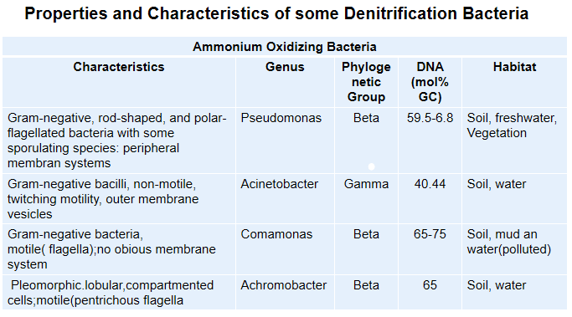

### ***1.2.2 Purification theory of Denitrifying Bacterial***

Nitrate reduction to nitrogen gas in anoxic conditions consists of 4 steps, including: bacteria-induced reduction of NO3- into NO2- , then NO2- more reduced into NO, N2O and N2

According to the traditional denitrification theory, the presence of oxygen can inhibit denitrification enzyme synthesis or denitrifying enzyme activity, and because oxygen competes with nitrate for electrons during the denitrification process, denitrification can only occur in an anoxic environment. In recent years, it has been discovered that some denitrifying enzymes can be synthesized and function under aerobic conditions, and that some denitrifying enzyme activities of bacteria are unaffected by dissolved oxygen, allowing oxygen and nitric nitrogen to be used as electron acceptors at the same time. The primary enzymes involved in aerobic denitrification are nitrate reductase (NAR), nitrite reductase (NIR), nitric oxide reductase (NOR), and nitrous oxide reductase (NOR) (N2OR)

1. Nitrate Reductase (NAR):- Nitrate reductase catalyzes the first step of the denitrification process, the process of nitrate reduction to nitrite. There are two different types of nitrate reductase, i.e., membranous nitrate reductase (NAR) and periplasmic nitrate reductase (NAP) :
2. Nitrite Reductase (NIR):- Nitrite reductase is the key enzyme of the denitrification pathway. The reduction reaction of nitrite to NO is a marked reaction between denitrification and other nitrate metabolism:
3. Nitric Oxide Reductase (NOR):- NO reductase plays a key role in the process of denitrification it participates in the aerobic denitrification process. NO reductase has a high affinity for NO; it can be limited to the concentration of electrons for NO reduction, thereby reducing the concentration of NO maintained at a very low level and to avoid the body itself caused by toxic effects:

1. N2O Reductase (N2OR):- The final step of the denitrification process N2O reductase catalysis is the reduction of N2O to N2:



### ***1.2.3 Factors that Influence the Rate of Denitrification***

* Concentration of Nitrate

Researchers have looked into the impact of nitrate content on the denitrification process and come up with a variety of conclusions. Higher nitrate removal efficiency is possible with heterotrophic bacteria. Nitrate concentrations ranging from 20 mg/L to 150 mg/L increase the rate of nitrate removal.

* pH

According to several studies, the ideal pH for denitrification is between and. Denitrification is hindered by nitrite buildup in the presence of a pH greater than 7.5. The pH can be kept around 7 with phosphate buffers, although the denitrification process will be less efficient if there is a significant concentration of phosphate buffer in the biofilm.

* Temperature

Denitrification requires a temperature range of 2°C to 50°C. The best temperature range for this technique has been reported by researchers to be 25°C to 35°C.

# Anammox

Ammonia is converted to nitrogen gas utilizing nitrite as an electron acceptor in the Anammox process. Anammox bacteria were found in a denitrifying bioreactor in 1992. The Anammox process is the most used method for removing ammonia because of its reduced costs. As a result, numerous studies have been conducted in this field. During the anaerobic digesting process, the anaerobic methanogenic bacteria consume organic materials as their main energy source. However, it is also utilised by heterotrophic denitrifiers in wastewater, reducing methanogenic bacterial energy production. Using autotrophic microorganisms to remove nitrogen leaves organic debris for methanogenic bacteria during wastewater treatment. Autotrophic nitrogen removal methods include denitrification, photo-autotrophic systems, and anammox. They are all intriguing, but the anammox procedure appears to be the most promising.

### ***1.3.1. Properties and Characteristics of Anammox bacteria***

The phylum Planctomycetes has six anammox bacterial genera, including Candidatus Kuenenia, Ca. Brocadia, Ca. Anammoxoglobus, Ca. Anammoximicrobium, Ca. Jettenia, and Ca. Scalindua. These six genera have been confirmed. The first five are usually found in wastewater treatment and freshwater systems, whereas the last is commonly found in salty conditions like sea water and sediments. The distribution of anammox bacteria types is greatly influenced by physiology and the environment. Ca. Brocadia anammoxidans, Ca. Jettenia, Ca. Anammoxoglobus, and Ca. Kuenenia predominate under low nitrogen loading rate (NLR) conditions, whereas Ca. Brocadia sinica and Ca. Kuenenia stuttgartiensis predominate under high NLR conditions. At temperatures ranging from 25 - 45℃, Ca. Brocadia and Ca. Brocadia fulgida are the most common species, with K. stuttgartiensis being found only in the extremes of the range. Although just a few anammox bacteria have been isolated successfully, they typically grow as extremely compact spheres with diameters ranging from 0.6 to 1.0 m. Until now, the majority of investigations have concentrated on enhanced anammox bacteria in biological reactors.

Table 4 Properties and Characteristics of some Anammox bacteria

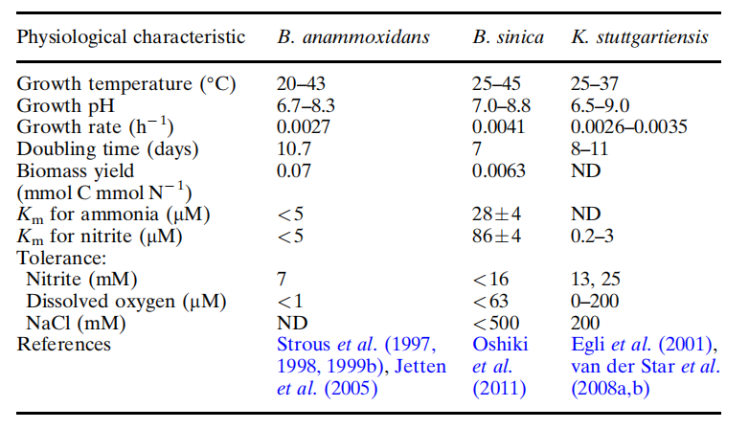

**_________________________________________________________________________**

Numerous studies using a variety of reactor layouts, operational parameters, and growth conditions have found varying amounts of anammox bacteria.  According to research,  purity of anammox enrichment was determined to be 97.6% in a membrane bioreactor (MBR) injected with 60–80% purity granular anammox from the first full-scale anammox reactor. When seeded with cultured activated sludge containing less than 10% anammox bacteria, the purity of enriched anammox bacteria can reach up to 97.7 percent.

### ***1.3.2 Purification theory of Anammox Bacterial***

Anammox bacteria grow on the conversion of ammonium and nitrite with CO2/bicarbonate as the sole carbon source and nitrite as the main electron acceptor. Operating under steady-state conditions in lab-scale bioreactors, the compounds are metabolized according to the equations below. The importance of biological stoichiometry in system design and optimization cannot be overstated. Specifically, during anammox, the ammonia-to-nitrite ratio is critical for system control and nitrogen removal. As a result, numerous studies have been conducted in this field. Anammox's balanced reactions are as follows:

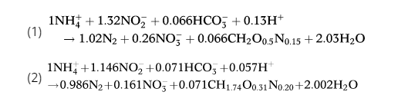

Almost 11% of the nitrogen load is transformed to nitrate in steady-state circumstances. As nitrate is a more readily available energy source in anoxic settings, constitutive expression of nitrite oxidoreductase (NXR) may allow anammox bacteria to utilise NO2 more quickly. Also, NXR is found in physiologically diverse bacteria (dNOB), and both sNOB and dNOB may contribute to excess nitrate generation in anammox systems.

It also requires energy from the substrate usage to produce microbial compositions such as extracellular polymeric substances (EPS) and soluble microbial products (SMP). The allocation of energy to EPS formation during exponential development may restrict planktonic anammox bacterial growth, whereas immobilized cells may employ most of the energy for cellular expansion.

### ***1.3.3 Factors that Influence the Rate of Denitrification***

* Free Ammonia and Ammonium

Some research stated that free ammonia (FA), even in low concentrations, restricts Anammox process more than ammonium ion. Recent investigations, however, demonstrate that FA concentrations of less than 13-38 mg/L have little influence on the Anammox process.

* Nitrite

Anammox bacteria are restricted by high nitrite concentrations.

* Organic Materials

There will be some competition between heterotrophic denitrifying bacteria and Anammox bacteria if there is an organic carbon resource. This is induced by heterotrophic bacteria's rapid proliferation in the presence of organic carbon. Heterotrophic bacteria can eradicate Anammox bacteria when the C:N ratio is greater than 2. Furthermore, some organic compounds, such as methanol, are toxic to Anammox bacteria and slow down the process.

* Oxygen

Anammox bacteria are anaerobic. So oxygen restricts their activity. However, some researchers announced that low oxygen concentrations do not restrict Anammox activity.

* Salinity

The Anammox process is influenced by salinity. Anammox bacteria, on the other hand, can grow in both fresh and salt water. As a result, this approach could potentially be employed in the treatment of salty wastewater, however salt has a threshold inhibitory effect on bacteria. According to one study, 30 g/L NaCl can reduce the Anammox process by up to 67.5 percent. According to some researchers, 6 g/L NaCl has little influence on Annamox activity, whereas 7.5 g/L KCl and 7.1 g/L Na2SO4 inhibit it. In addition, salinity of 3-15 g/L NaCl promotes the production of Anammox granular sludge.

* Temperature and pH

The Anammox process is influenced by salinity. Anammox bacteria, on the other hand, can grow in both fresh and salt water. As a result, this approach could potentially be employed in the treatment of salty wastewater, however salt has a threshold inhibitory effect on bacteria. According to one study, 30 g/L NaCl can reduce the Anammox process by up to 67.5 percent. According to some researchers, 6 g/L NaCl has little influence on Annamox activity, whereas 7.5 g/L KCl and 7.1 g/L Na2SO4 inhibit it. In addition, salinity of 3-15 g/L NaCl promotes the production of Anammox granular sludge.

# 1.1 Biological Nitrogen Removal (BNR) Theory and Technology

# 1.1.1 The Traditional BNR Theory and Technology

Based on bacterial metabolisms, the traditional biological nitrogen removal idea involves successive nitrification and denitrification. To begin, heterotrophic bacteria degrade organic nitrogen in wastewater and convert it to ammonia nitrogen, which is a pretty simple process. Second, autotrophic Ammonia-oxidizing bacteria (AOB) oxidize ammonium (NH4+) to nitrite (NO2) via hydroxylamine (NH2OH) in the first phase of nitrification (reactions 1 and 2, below).







These two processes are catalyzed by membrane-bound ammonia monooxygenase (AMO) and hydroxylamine oxidoreductase (HAO). In the second phase, nitrite-oxidizing bacteria (NOB) use membrane-bound nitrite oxidoreductase (NOR) to convert nitrite to nitrate (NO3) (reaction 3).

NO3- and NO2- are reduced to gaseous nitrogen in anoxic denitrification using a number of electron donors, including methanol, acetate, and organic compounds found in wastewater (reactions 4 and 5).





By working together, AOB and NOB are able to finish the nitrification process. Finally, denitrification occurs when nitrate in wastewater is transformed to gaseous nitrogen by heterotrophic denitrifying bacteria. Nitrification requires aerobic conditions, as the general requirement for dissolved oxygen is greater than 2.0 mg L 1, and inorganic carbon as a carbon source is required for bacterial growth and metabolism; denitrifying bacteria require organic carbon for cell growth, which can only be accomplished under hypoxic conditions. To ensure a lowering environment, the dissolved oxygen level should be below 0.5 mg L 1.The combined activity of microorganisms in the microbial community drives biological wastewater treatment. As a result, it is critical to understand the nitrogen removal processes as well as the microbial communities involved in the processes. The combined activity of microorganisms in the microbial community drives biological wastewater treatment. As a result, it is critical to understand the nitrogen removal processes as well as the microbial communities involved in the processes.

The biological denitrification process based on the traditional biological denitrification theory can only separate the nitrification and denitrification processes, such as A/O, the most common pre-denitrification process based on activated sludge, due to the different requirements of nitrifying bacteria and denitrifying bacteria for nutrients and dissolved oxygen (Fig. 1.1). However, this

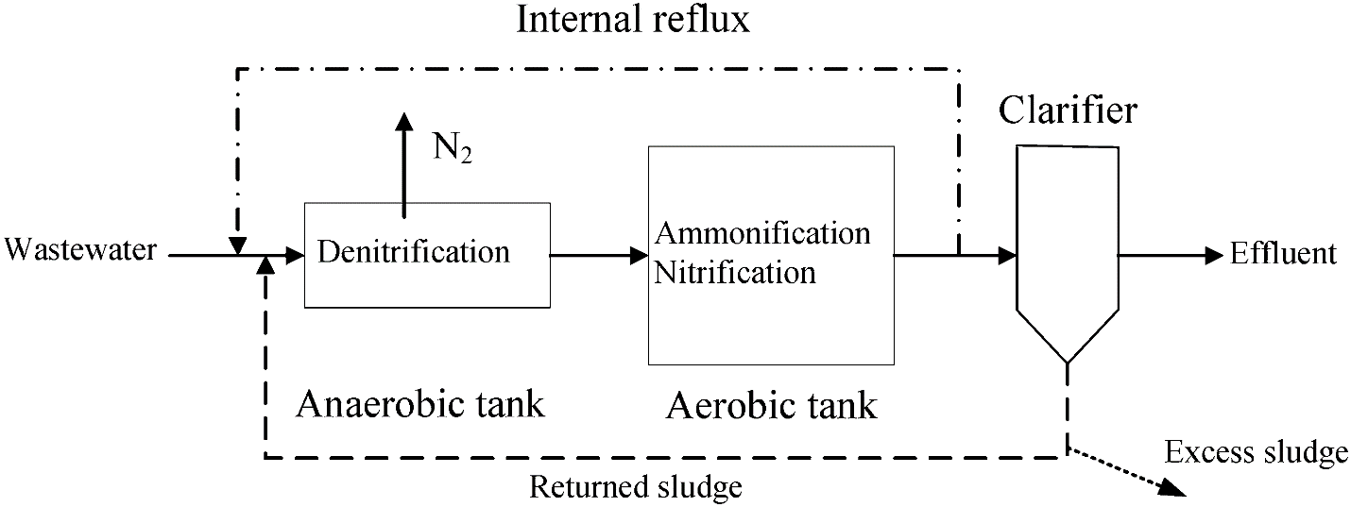

Figure 1‑1 Conventional A/O biological nitrogen removal activated sludge process

separation has a number of disadvantages, including increased infrastructure and operational expenses, the need for more alkali and carbon, and so on.

# 1.1.2 The New BNR Theory and Technology

In recent years, with in-depth research of microbiology and knowledge of biotechnology, bio-denitrification technology has been further developed from the simple process to the biological characteristics of the process to encourage the development direction of reform in order to reach the high efficiency and low consumption objectives. Some processes break through the traditional biological denitrification theories such as anaerobic ammonium oxidation (ANAMMOX), shortcut nitrification and denitrification, simultaneous nitrification and denitrification, and aerobic denitrification. Aerobic denitrification and other new biological nitrogen removal process more and more attention.

## Anaerobic Ammonium Oxidation (ANAMMOX)

Anaerobic ammonium oxidation is a biological oxidation process in which microorganisms directly convert ammonia nitrogen (as an electron donor) and nitrite nitrogen (as an electron acceptor) to nitrogen gas under anaerobic conditions. Mulder et al. (1995) discovered ammonia nitrogen losses and nitrogen generation in a fluidized bed reactor for anaerobic denitrification. For the first time, anaerobic ammonium oxidation was described. At the moment, the researchers have developed an affinity for a range of anaerobic ammonia-oxidizing bacteria, a type of energy autotrophic bacteria that are primarily found in mold fungi (Schmidt et al. 2003).

In comparison to conventional nitrogen removal processes, anaerobic ammonium oxidation saves carbon, reduces energy consumption, and lowers sludge disposal costs. It also has obvious implementation and operating cost advantages for wastewater with a high ammonia nitrogen content and a low carbon to nitrogen ratio. However, because the anaerobic ammonium oxidation bacteria reproduce at a very slow pace, the generation cycle is quite protracted, and so the primary issue is the lengthy startup time. Additionally, because the organic substance in the sewage results in heterotrophic bacteria multiplying and autotrophic bacteria forming competitive inhibition in the reactor matrix, normal metabolism is disrupted. Thus, how to maintain anaerobic ammonia oxidation bacteria in the reactor's function stability is another pressing issue.

## Shortcut Nitrification and Denitrification

Traditional biological denitrification theory requires two steps of nitrification and denitrification. Ammonia nitrogen is converted to nitrite by ammonia-oxidizing bacteria (AOB) and subsequently to nitrate by nitrite-oxidizing bacteria (NOB). Denitrification is a process that utilizes nitrification products such as nitrate and nitrite as electron acceptors in order to reduce gaseous products produced by bacteria. In this case, short-range nitrification and denitrification can occur if the ammonia nitrogen is oxidized to nitrite without further oxidation to nitrite. Compared to the traditional nitrification and denitrification processes, nitrification-denitrification saves 25% oxygen and 40% carbon supply, decreases end sludge output, reduces nitrification process alkali dose, and reduces reactor volume by 30–40%.

Theoretically, ammonia-oxidizing bacteria and nitrite-oxidizing bacteria have different optimal survival conditions. An artificial environment promotes ammonia-oxidizing bacteria growth but inhibits nitrite-oxidizing bacteria. The oxidizing bacteria are enriched in the reactor and outcompete the nitrite-oxidizing bacteria. So the nitrite nitrogen can be accumulated in the reactor to finish the nitrite denitrification process. The SHARON (single reactor for high activity ammonia removal over nitrite) and OLAND (oxygen-limited autotrophic nitrification-denitrification) processes are both used in the treatment procedure.

Controlling ammonia during the nitrite stage is the key to reducing the time it takes for nitrification, and nitrite serves as a denitrification electron acceptor. Nitrogen dioxide (DO) and free ammonia all influence nitrite buildup. Temperature is also a factor. This difference becomes more pronounced at temperatures greater than 15 C, where the sludge age of ammonia-oxidizing bacteria is shorter than that of nitrite-nitrifying bacteria. So you can use a sludge age with a high temperature control to stop the growth of nitrifying bacteria that take longer to produce nitrite. Ammonia-oxidizing bacteria and nitrite-oxidizing bacteria grow at different rates at different pH values, resulting in nitrite buildup. pH ranges from 7.5 to 9.0. As pH rises, so does the concentration of nitrite in the solution. It has been found that when ammonia is exposed to oxygen, its nitrite content rises dramatically, hence it is possible to keep the dissolved oxygen concentration low enough to achieve nitrite buildup. Because higher levels of free ammonia limit nitrite oxidation, it is possible to accomplish faster nitrification and denitrification when treating wastewater with high ammonia concentrations.

## Simultaneous Nitrification and Denitrification

Denitrification has always been regarded as a strictly anaerobic process in traditional nitrification and denitrification concepts. Denitrifying bacteria, being facultative bacteria, prefer to breathe with O2, even at DO concentrations as low as 0.1 mg L-1, preventing them from using nitrate or nitrite as electron acceptors. However, in recent years, non-assimilative total nitrogen loss under aerobic conditions has been routinely seen in practice, and total nitrogen losses have exceeded 30% in many practical aerobic nitrification tanks (Daigger and Littleton 2000). The phenomena of simultaneous nitrification and denitrification are primarily explained by macroscopic environmental theory, microenvironmental theory, and microbiological theory.

According to macroenvironmental theory, even in aerobic activated sludge systems with point source aeration, there will be a large range of local anoxic environments. In biofilm reactors, anoxic zones occur in the membrane due to fluctuations in substrate concentration and film thickness. Similar processes include SBR reactors and oxidation ditches. Because a production-scale bioreactor does not have a totally homogeneous mixing condition, simultaneous nitrification and denitrification is conceivable during the aeration stage. According to the microenvironmental theory, oxygen diffusion limitation causes a dissolved oxygen gradient in microbial flocs or biofilms, supporting the growth of aerobic nitrifying bacteria. In-depth flocs generate hypoxic environments because to oxygen transmission and external oxygen consumption, allowing denitrifying microorganisms to reduce nitrate. This allows for simultaneous nitrification and denitrification in sludge flocs.

According to microbiological theory, aerobic denitrifying bacteria can consume oxygen and nitrate or nitrite as electron acceptors and contribute significantly to total nitrogen removal. This theory also disproves the old anaerobic denitrifying bacteria notion. Simultaneous nitrification and denitrification allows combining the two processes in one reactor, saving space and resources. Alkalinity dose can also be lowered because denitrification produces alkalinity to compensate for nitrification. This reduces reaction time, saves aeration, and reduces carbon source usage.

# Major biological enzymatic nitrogen cycle mechanisms that oxidize nitrogen

Organic nitrogen and ammonium are the most common types of nitrogen found in water after initial wastewater treatment. During secondary treatment, nitrifying bacteria such as ammonium oxidizing bacteria (AOB) and nitrite oxidizing bacteria (NOB) rapidly convert these two primary forms of nitrogen to nitrate (Taziki et al., 2015). Complete ammonia oxidizers (Comammox) that have recently been discovered may execute ammonia oxidation to nitrate (Daims et al., 2015).

Nitrite is the most volatile type of nitrogen found in the environment. It is the least prevalent type of inorganic nitrogen in both wastewater treatment systems and surface waterways. Among the nitrogen cycle biological processes described above, nitrification, denitrification, anammox, and nitrogen assimilation are presented in this report.

# Reference

Du, R., Y. Peng, S. Cao, S. Wang and C. J. B. t. Wu (2015). "Advanced nitrogen removal from wastewater by combining anammox with partial denitrification." **179**: 497-504.

Hord, N. G., J. S. Ghannam, H. K. Garg, P. D. Berens and N. S. J. B. M. Bryan (2011). "Nitrate and nitrite content of human, formula, bovine, and soy milks: implications for dietary nitrite and nitrate recommendations." **6**(6): 393-399.

Magdum, S., V. J. R. J. o. C. Kalyanraman and Environment (2017). "Existing biological nitrogen removal processes and current scope of advancement." **21**(7): 43-53.

Melcer, H., C. B. Bott, P. Regmi, L. Rieger, J. Wan, C. Johnson, K. Chandran and Y. J. P. o. t. W. E. F. Ma (2013). "Measuring Nitrite-The Key to Controlling Deammonification Systems." **2013**(4): 748-757.

Rezvani, F., M.-H. Sarrafzadeh, S. Ebrahimi, H.-M. J. E. S. Oh and P. Research (2019). "Nitrate removal from drinking water with a focus on biological methods: a review." **26**(2): 1124-1141.

Ritter, K. S., Paul Sibley, Ken Hall, Patricia Keen, Gevan Mattu, Beth Linton, Len %J Journal of Toxicology and E. H. P. A (2002). "Sources, pathways, and relative risks of contaminants in surface water and groundwater: a perspective prepared for the Walkerton inquiry." **65**(1): 1-142.

Zekker, I., E. Rikmann, T. Tenno, A. Saluste, M. Tomingas, A. Menert, L. Loorits, V. Lemmiksoo and T. J. E. t. Tenno (2012). "Achieving nitritation and anammox enrichment in a single moving-bed biofilm reactor treating reject water." **33**(6): 703-710.

Murnleitner, E., Kuba, T., Van Loosdrecht, M. C. M., & Heijnen, J. J. (1997). An integrated

metabolic model for the aerobic and denitrifying biological phosphorus removal. Biotechnology

and Bioengineering, 54, 434–450.